Contents

Shortcut created in NJDPB 1

Place putty & rdp exe in current folder 2

Change putty appearance 3

Enable X11 forwarding in putty 9

Putty session 9

windows remote desktop 9

# Shortcut created in NJDPB

## Place putty & rdp exe in current folder

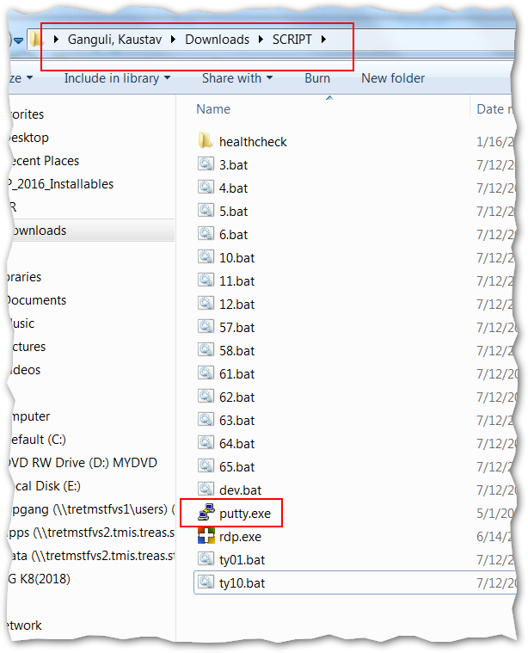

## Change putty appearance

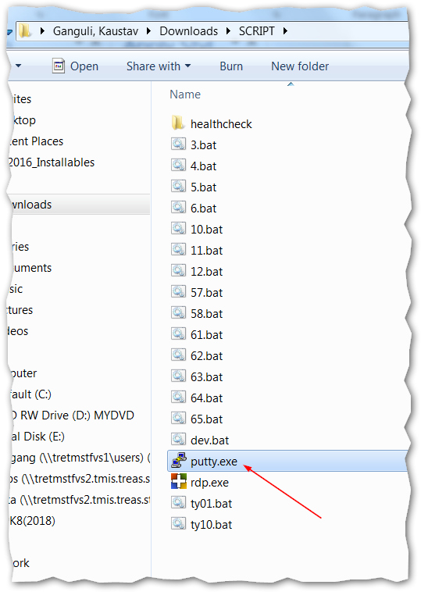

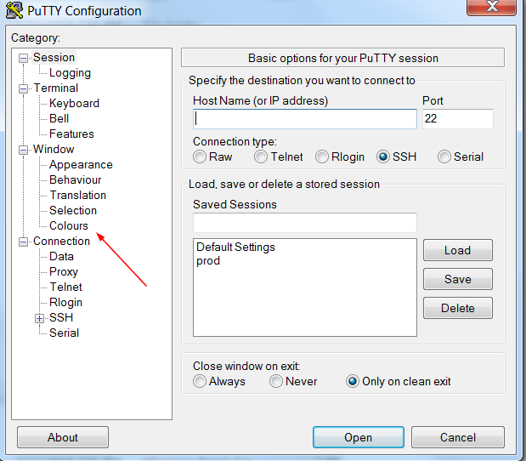

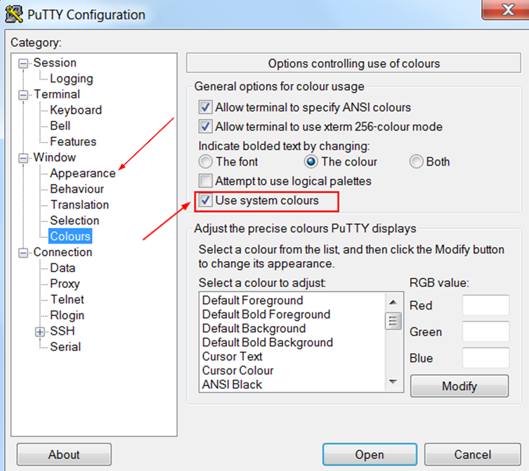

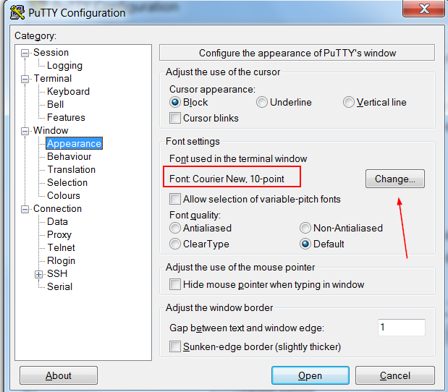

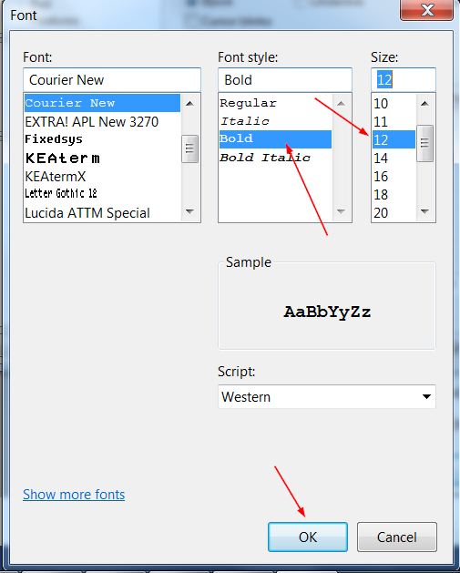

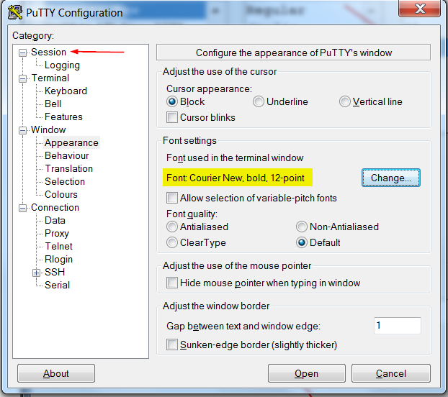

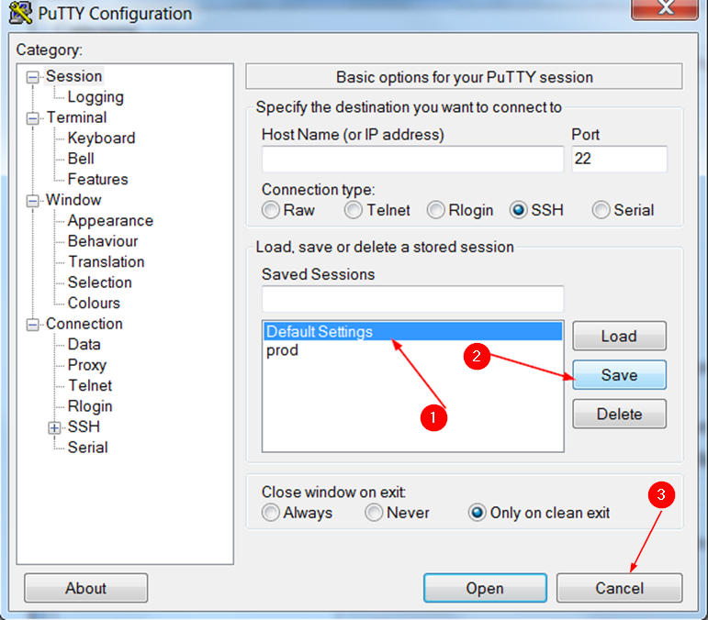

## Enable X11 forwarding in putty

Google search and download xming and install it.

## Putty session

Create bat file with this command

start /MAX putty sadmin@Halsey03.sa -pw siebdev99 –X

-X is for X11 forwarding on Xming. Make sure Xming is running.

## windows remote desktop

Create bat file with this command

start rdp.exe /v:snja55.njes /u:snja55\vdikert /p:SiebelAdmin12!

The rdp.exe file is given in folder

Add the rdp and putty file in the user environment variable PATH

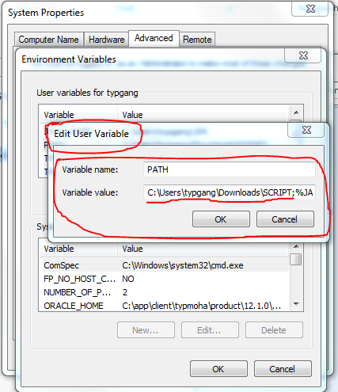

## ALIASes

alias **cdlog**='cd /siebprod1/SIEBEL_SES_AI/siebsrvr/enterprises/SBA_UPGDEV/srvr_1/log'

alias **siebsrvr**='. /siebprod1/SIEBEL_SES_AI/siebsrvr/siebenv.sh'

alias **gtwy**='. /siebprod1/SIEBEL_SES_AI/gtwysrvr/siebenv.sh'

alias **srvrmgr**='siebsrvr;srvrmgr -g ty-siebol-ma-x:9111 -e SBA_UPGDEV -u SADMIN -p siebdev99'

alias **ses_stop**='/siebprod1/SIEBEL_SES_AI/applicationcontainer_internal/bin/shutdown.sh'

alias **ses_start**='/siebprod1/SIEBEL_SES_AI/applicationcontainer_internal/bin/startup.sh'

alias **ai_stop**='/siebprod1/SIEBEL_SES_AI/applicationcontainer_external/bin/shutdown.sh'

alias **ai_start**='/siebprod1/SIEBEL_SES_AI/applicationcontainer_external/bin/startup.sh'

alias **genb**='. /siebqa1/siebel/8.2.2.0.0/ses/siebsrvr/siebenv.sh;genbscript /siebqa1/siebel/8.2.2.0.0/ses/siebsrvr/bin/enu/publicsector.cfg enu'

alias **change_srf**='cdlog;cd ../../../..;. ./siebenv.sh;cd objects/enu;datestamp siebel_sia.srf;scp /siebelsoft/SRF/siebel_sia.srf .;stop_server all;start_server all;genb'

#to show path in prompt

#PS1="\${PWD}\ :- "

PS1="`hostname`:\${PWD}\ :- "

#to get previous command keyboard shortcut ctrl+k/j

set -o vi